Exercise 2: Words as Data

What happens to your wordle when you change the settings?
First Wordle
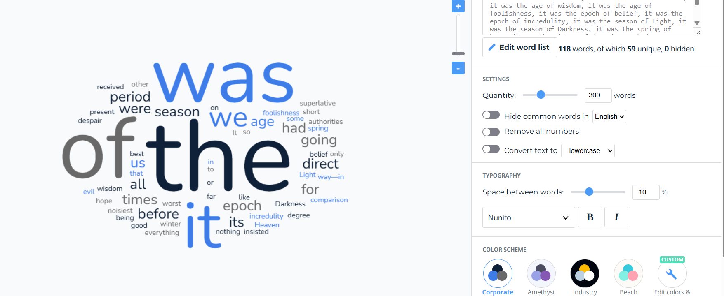

- Number of Words:
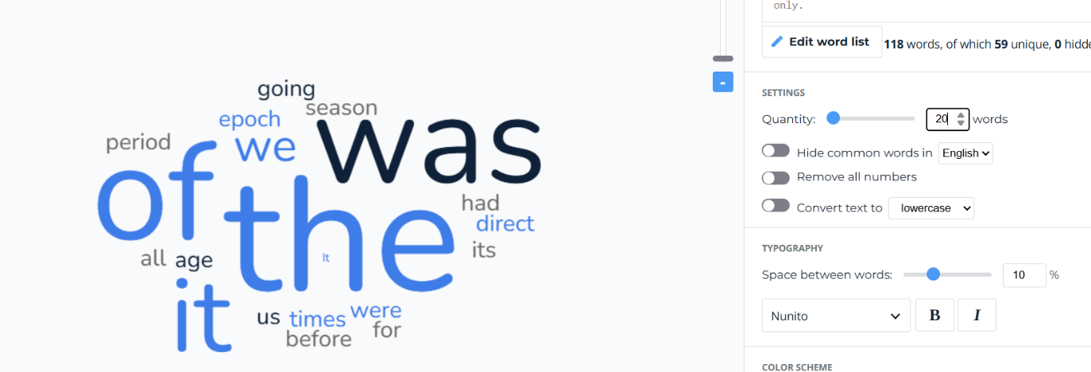
If you change the setting for the maximum number of words, the cloud will show more or fewer terms. A lower number shows only the most frequent words, while a higher number includes less common ones.
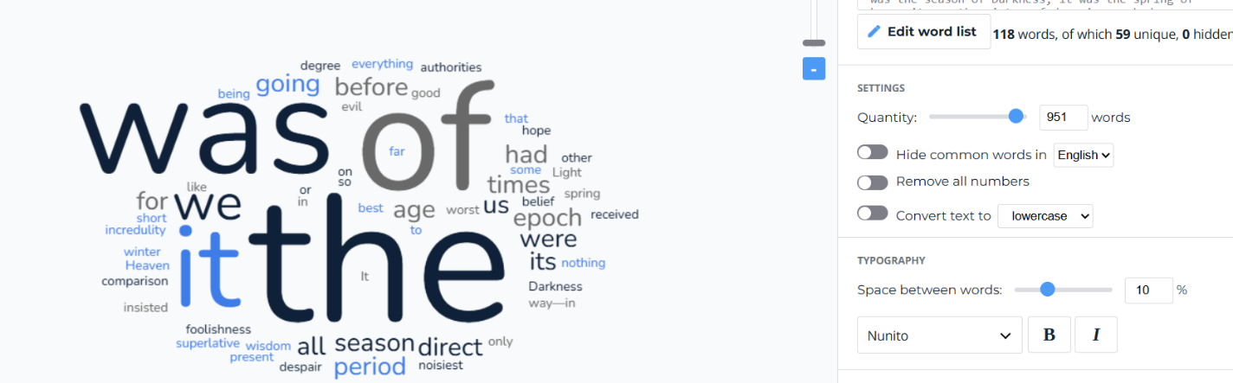
- Hide common words in (English): The generator usually has an option to remove "stop words" (like "it," "was," "the," "of"). Turning this on or off dramatically changes the cloud. With it on, the cloud focuses on meaningful content words like "times," "wisdom," "hope," and "despair." With it off, the cloud is dominated by common words like "the," "it," and "was," which are less informative.
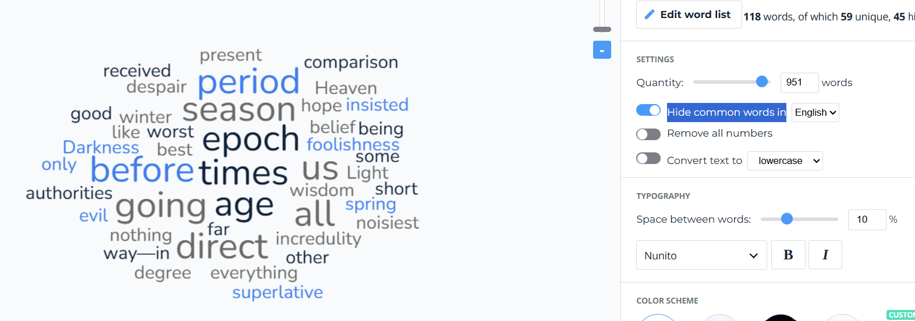

- Convert text to lowercase
If you turn this ON, words with capital letters are changed to lowercase. For example, “The” becomes “the.” This helps the website count “The” and “the” as the same word.
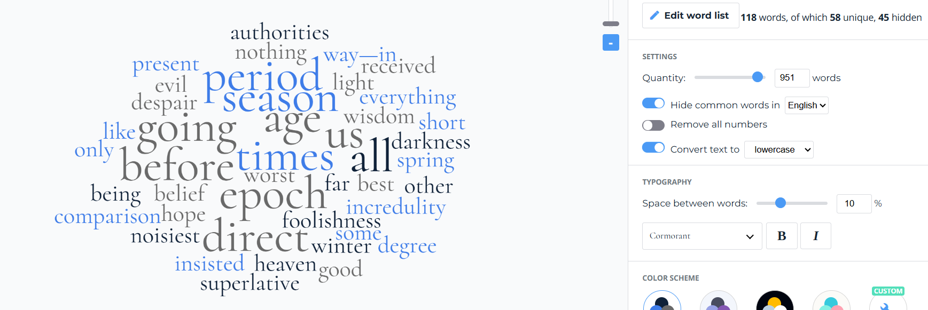

- Color and Font: These are purely aesthetic. Changing the color palette or font family alters the visual appeal but does not affect the underlying data analysis.
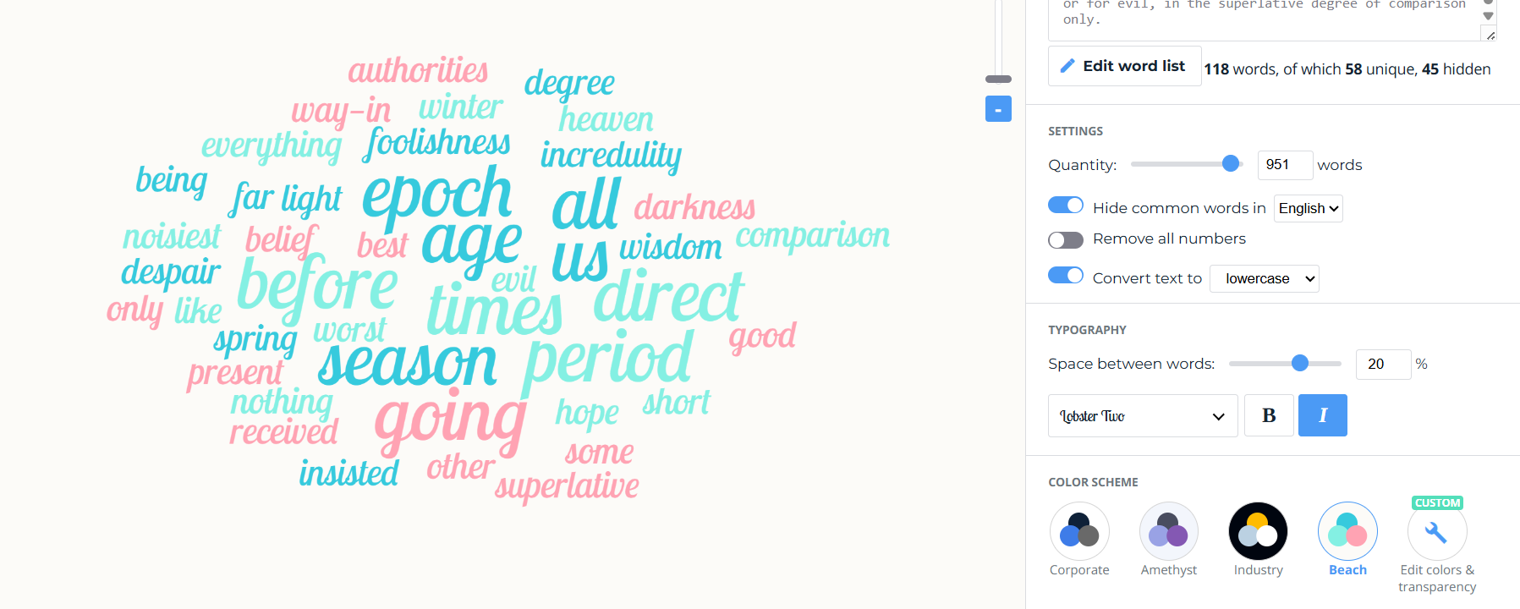

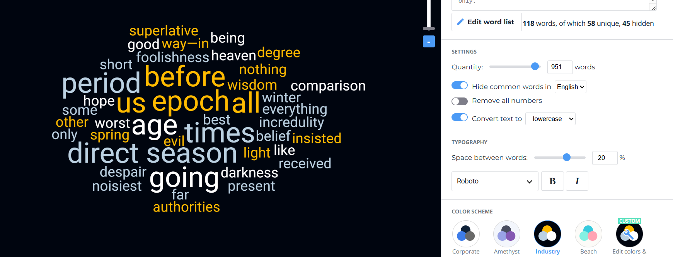

When I changed the settings in the word cloud, the appearance of the wordle changed. Some words became larger or smaller, the number of words displayed changed, and the layout and colours also changed depending on the settings.

What do you think is going on behind the scenes?
When I changed the settings in the word cloud, the appearance of the wordle changed. Some words became larger or smaller, and the number, arrangement, colours, and orientation of the words also changed depending on the settings.
I think that behind the scenes, the website is analyzing the text by counting how often each word appears. The code reads the text pasted into the box and then splits it into individual words. It converts all the words to lowercase and removes punctuation so that words like “The” and “the” are counted as the same word.
Next, the script counts how many times each unique word appears in the text. This is the main part of the analysis. If we choose to exclude common words, the script compares each word with a built-in list of stop words, such as “a,” “an,” “the,” “of,” and “for,” and removes them.
The size of each word is then determined by its frequency. The more often a word appears, the larger it will be in the word cloud. The website then arranges the words in a compact and visually pleasing layout based on the selected orientation, colours, and other settings. Finally, it displays the word cloud on the screen.
In summary, the process transforms raw text into structured data and then into a visual representation. Changing the settings allows us to filter and display the data in different ways, which can highlight different patterns and aspects of the text.

